### Employee Data Analysis using Excel



STUDENT NAME: V. Santhosh Kumar REGISTER NO: 422200597

DEPARTMENT: B.COM(InformationSystemManagement).

COLLEGE: SRM Arts And Science College.



 1



## PROJECT TITLE



**Employee Data Set Analysis**

**using Excel**





2

# AGENDA

1.Problem Statement 2.Project Overview 3.End Users

4.Our Solution and Proposition 5.Dataset Description 6.Modelling Approach 7.Results and Discussion 8.Conclusion

3

3/21/2024 **Annual Review**



## PROBLEM STATEMENT

To analyze the employee data set to identify key trends, patterns, and areas for improvement within the organization. This will help in making data-driven decisions related to workforce management, employee performance, and overall organizational efficiency.

 4



## PROJECT OVERVIEW

This overview provides a structured approach to the project, detailing the objectives, methodology, and expected outcomes. Adjust the details based on your specific project requirements and available data.

 5



### WHO ARE THE END USERS?

### HR Managers: To develop targeted employee engagement initiatives and improve HR policies.

### Senior Management: To guide strategic decisions and evaluate overall organizational performance.

### Line Managers: To improve team performance and manage day-to-day operational challenges.



6



**OUR SOLUTION AND ITS VALUE PROPOSITION**

#### Conditional Formatting:

To highlights the missing value of the data.

#### Filter:

To remove the missing value of the data.

#### Formula:

To find the employees performance level in the data.

#### Pivot Table:

To summary the employees data.

#### Graph:

To visualization of the employees data in the

organisation.

 7



# Dataset Description

* **Name**: Full name of the employee
* **Department**: The department where the employee works
* **Age:** The age of the employee.
* **Gender:** The gender of the employee (e.g., Male, Female, Non-Binary)
* **Salary/Compensation:** The employee’s base salary or total compensation package.
* **Empolyee Status:** Employment status (e.g., Full-Time, Part-Time, Contract)



## THE "WOW" IN OUR SOLUTION



**Performance level:**=SUMIF(D2:D100, "Training", E2:E100)

9

3/21/2024 **Annual Review**



# MODELLING

#### Identify what you want to achieve with your modeling. Common objectives might include:

#### Predicting employee turnover.

#### Analyzing the impact of training on performance.

#### Assessing factors influencing compensation.

#### 

 10



**Data Cleaning:**

**1.Conditional Formatting:**

To highlights the missing value of the data.

**2.Filter:**

To remove the missing value of the data.

**Performance level:**

=SUMIF(D2:D100, "Training", E2:E100)

#### Summary:

**1.Pivot Table:**

To summary the employees data.

**2.Graph:**

To visualization of the employees data in the organisation.



# RESULTS

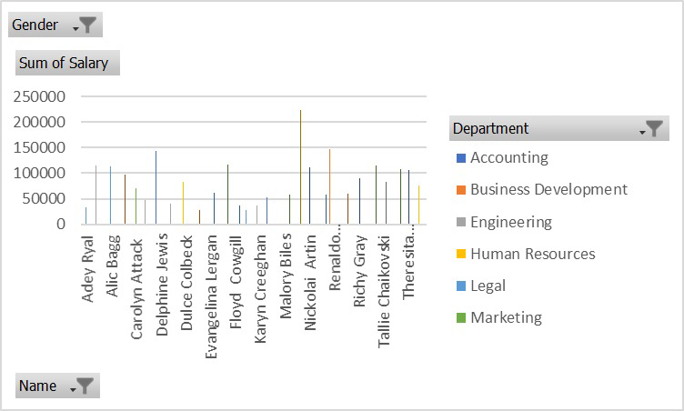

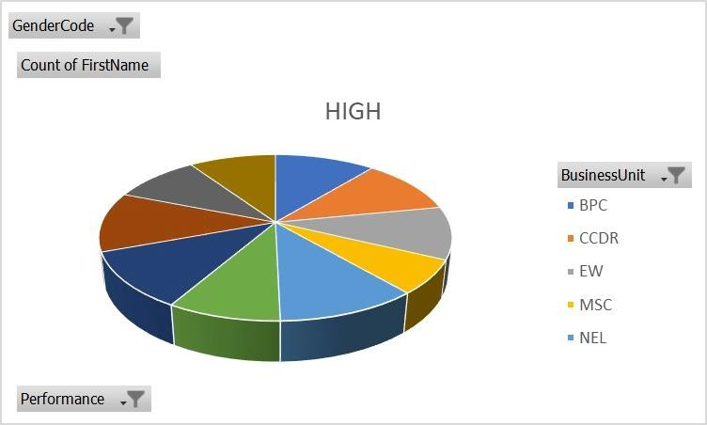

 1



Conclusion

After performing a comprehensive analysis of the

employee data set using Excel, several key insights

and conclusions can be drawn. This section summarizes

the findings, implications, and recommendations based

on the modeling and analysis conducted.